**A-Arms conception and manufacturing**



***Objectives***

* **Reliability** 
  + Maximal load case on the car: 6250 N
* **Weight**
  + Target of 2 kg
* **Cost**
  + Ratio of comparison of weight saving < 1 euros by grams

***Conception and manufacturing steps***

* [**Comparisons**](https://www.linguee.fr/anglais-francais/traduction/requirements+analysis.html) **of different solutions**: Comparison of a steel solution, an aluminium solution and an hybrid solution (aluminium + carbon tubes).
* **Validation of the process**: tensile strength.
* **Verification of the A-arms**: tensile test after integration.

[***Comparisons***](https://www.linguee.fr/anglais-francais/traduction/requirements+analysis.html) ***of the 3 designs***

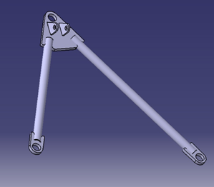 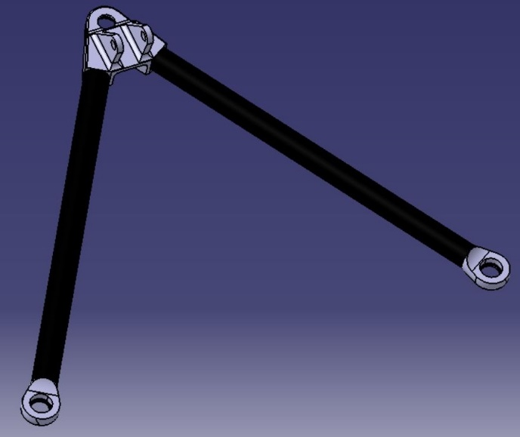

*Steel design (left) and hybrid design (right) represented*

* **Steel design:** Laser cutted part with tubes, assembled together by welding
* **Aluminium design:** Machined parts with tubes, assembled together by welding
* **Hybrid solution:** Aluminium machined parts with carbon tubes, assembled together with glue

|  |  |  |  |
| --- | --- | --- | --- |
| **Design** | **Steel** | **Aluminium** | **Hybrid** |
| **Cost estimation** | 600,00 € | 2 010,00 € | 3 350,00 € |
| **Weight estimation (g)** | 5980 | 3070 | 1840 |
| **Ratio €/g decrease (comparison with steel)** |  | 0,49 € | 0,66 € |

*Comparisons of the cost and weight of the 3 designs*

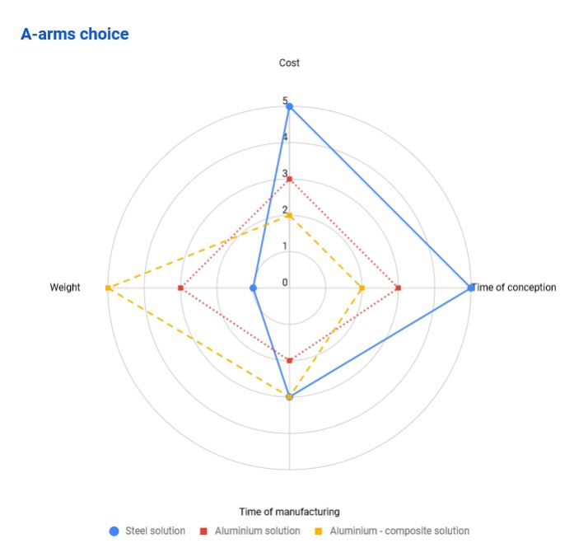

* Aluminium-carbon composite design chosen to achieve the 2 kg target.

***Process of gluing***

|  |  |
| --- | --- |
| **Gluing surface** | 1,13E-03 (carbon-alu)/ 0,75E-03 (alu-alu) |
| **Theoretical maximum shear stress of epoxy structural adhesive used (from datasheet, for a contact between two plates)** | 30.2 MPa |
| **Worst load case (obtained with MecaMaster)** | 6,25 kN |
| **Minimal tensile strength to reach for our process (with a security coefficient of 2.5)** | 15 kN |

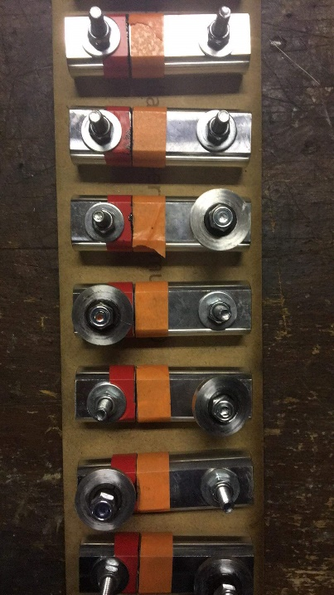**Process flow**

**Step 1: sanding**

* Sanding of the aluminium parts with sandpaper P180
* Sanding of the carbon tubes with sandpaper P180
  + 3 times on a length of 30 mm
  + Visual control

**Step 2: cleaning with acetone**

* 2 times for aluminium parts and carbon tubes
* Let evaporate after

**Step 3: Gluing**

* Application of the epoxy structural adhesive on the inserts

parts all along the surface

* Insert it by turning
* Place it and fix it on the fixture

**Step 4: Drying**

* Let it dry for 7 days at 20°C

**Gluing tests**

Tensile strength tests on 10 gluing aluminium-aluminium and 10 gluing carbon tube – aluminium.

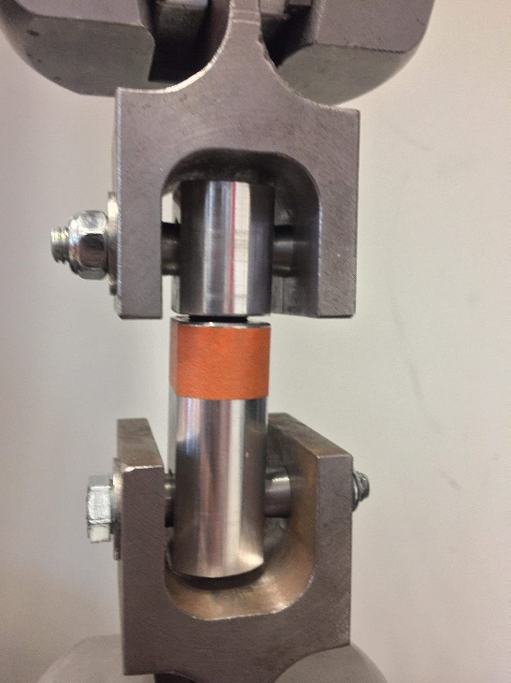 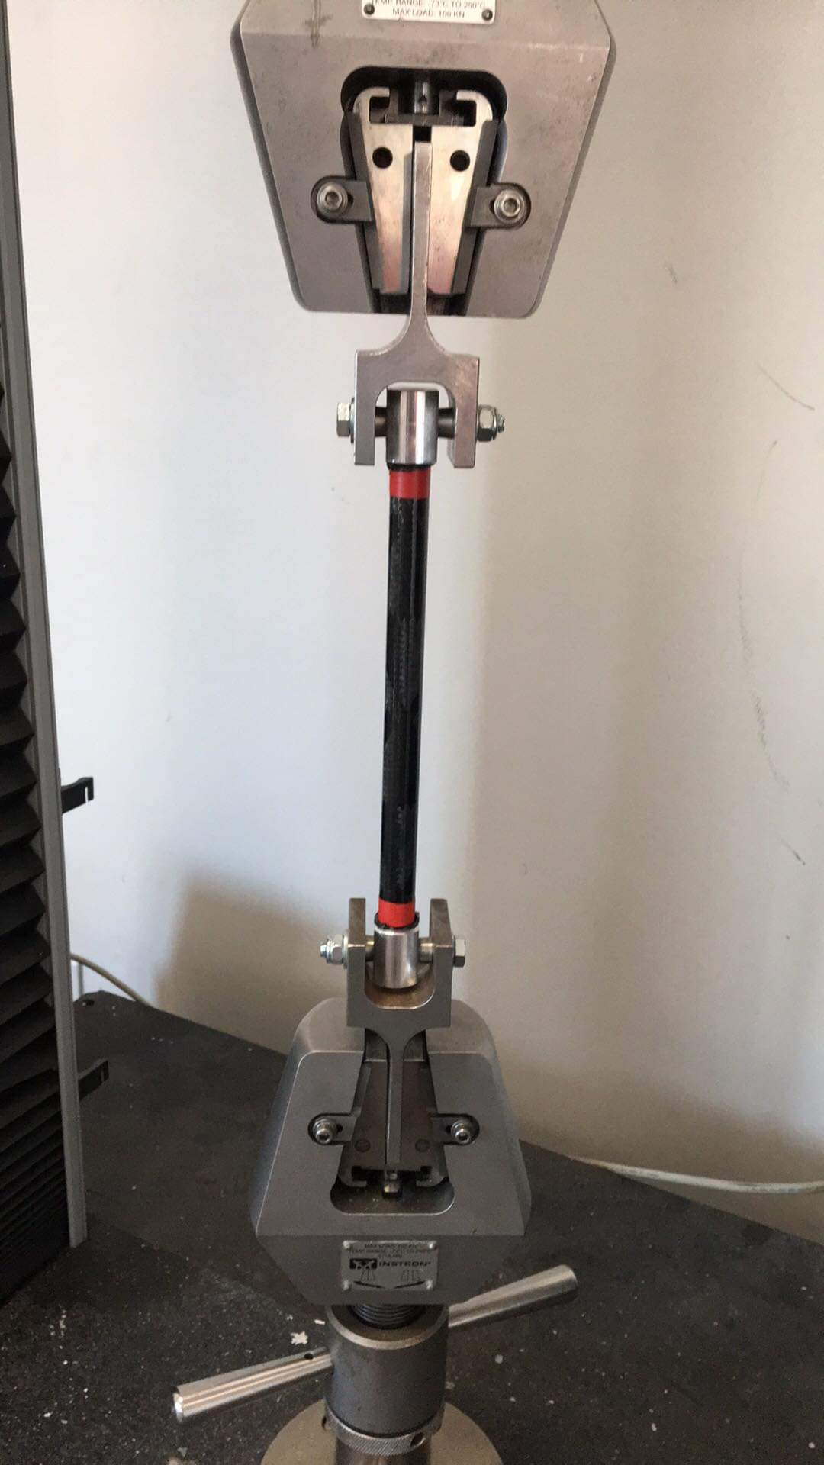

|  |  |  |
| --- | --- | --- |
|  | **Carbon-alu** | **Alu-alu** |
| **Standard deviation** | 1,73 | 0,33 |
| **Mean** | 20,02 | 15,97 |
| **Min.** | 16,9 | 15,50 |
| **Max.** | 22 | 16,50 |
| **Confidence interval (99%)** | 4,45 | 0,85 |
| **Min. of confidence interval** | 15,57 | 15,12 |

***Verification of current A-arms***

